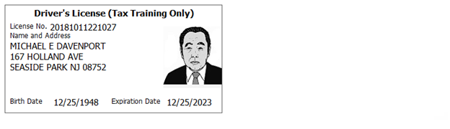
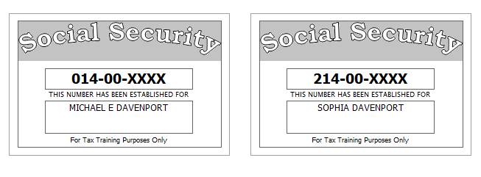
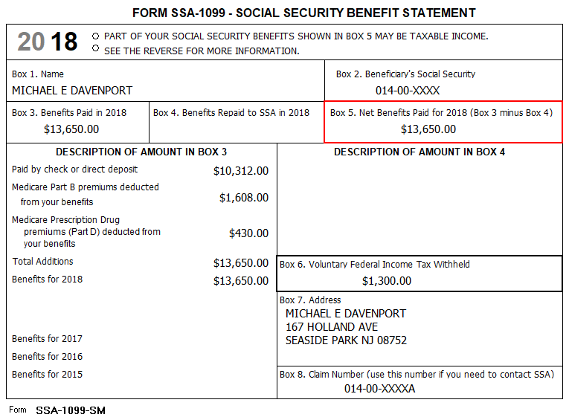
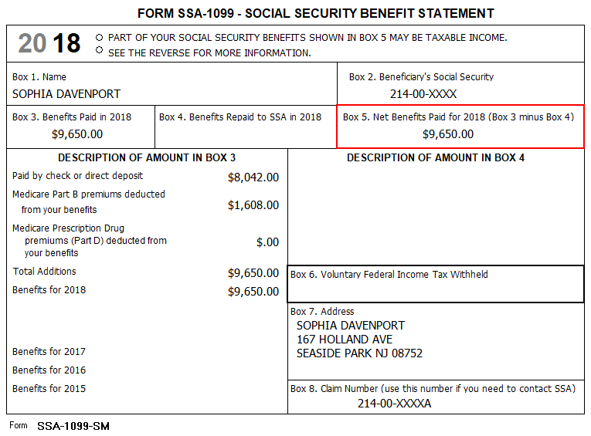

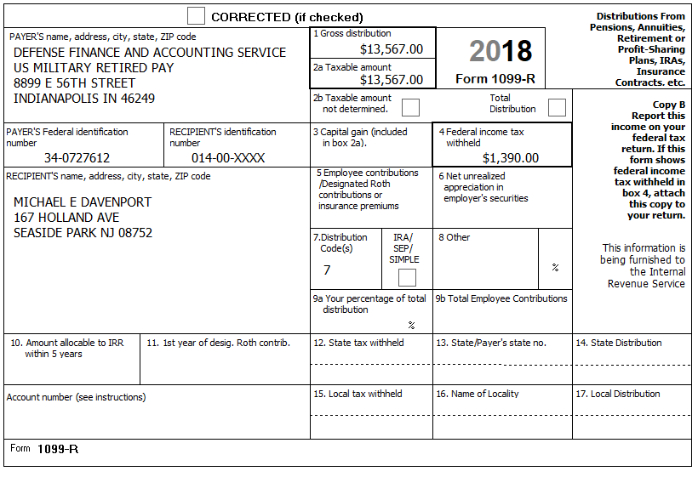
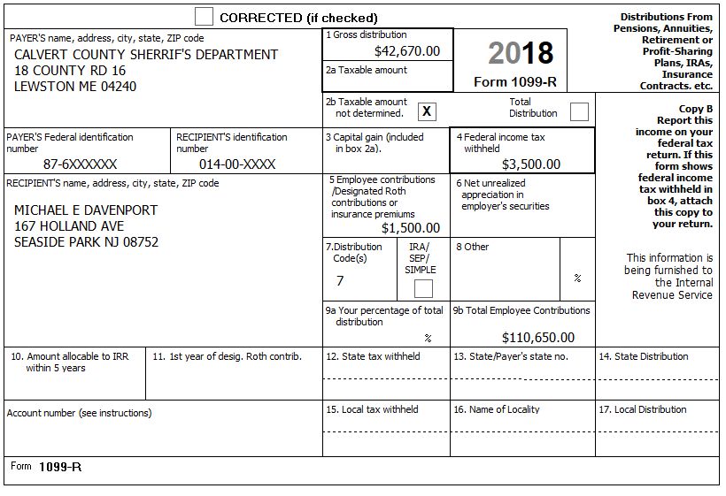
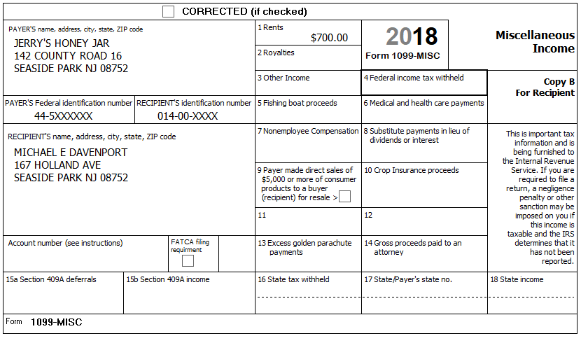

The Davenports have itemized their deductions in the past and though the standard deduction has increased, they believe because of substantial out-of-pocket medical expenses they may be able to itemize. They keep excellent records and provide the following summary:

Medical and dental expenses
Doctors: ....................................... $1,789.00 Ambulance ......................... $960.70
Dental insurance: ........................ $1,616.00 Hospital............................ $3,790.23
Dental crowns: ............................ $2,178.34 Insulin.................................. $980.00
Prescriptions: ............................... $1795.57 Hearing aids ..................... $3,195.90
Medical miles: ............................... 1,843
Taxes paid
Property tax on a parcel of land: $450.00
Personal Property tax on two vehicles (value based): $318
Use Zip Code 08752 for sales tax
In 2018, they received a Homestead Benefit credit from NJ of $425
In 2018 they received a PTR rebate of $1,150
The Davenport’s PTR base amount is $5,000. Block # 2345, Lot # 7
Michael is a Veteran and did receive the Annual Deduction for Veterans of $250 from his property tax.
Interest Paid
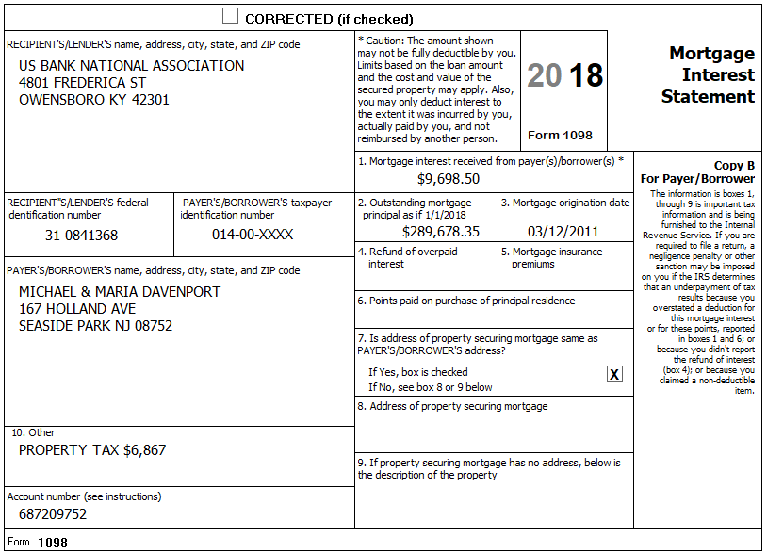
Reminder: Include the property tax/real estate tax when entering the mortgage interest.
Gifts to Charity
St Peter’s Church: ......................... $2,600.00 Chamber of Commerce..................... $75.00
Mayo Clinic: .................................. $1,000.00 Republican National Party ................$50.00
American Red Cross: ....................... $500.00 AARP Foundation............................ $100.00
Goodwill (clothing/household) ....... $418.00
Miscellaneous Deductions
Safe deposit box: ............................ $300.00
Investment fees: .......................... $1,978.00
Tax return preparation: .................. $675.00

Prior Year Return
- The Davenports did bring their prior year return that was prepared by a paid preparer. From the prior year return you determine
  - They did itemize and take a property tax deduction. After some discussion you determined that they have been itemizing and taking property tax deductions for the past 3 years
  - Line 13 on page 1 of the 1040 is -3,000. Looking into the return you find a copy of a “Capital Loss Carryover Worksheet” and you see that line 8 (Short-term capital loss carryover) for 2017 is $1,309.
- 1040 Values: Line 8b=100, Line 16a=53,300, Line 16b=47,295, Line 20a=21,300, Line 20b=18105, AGI=65,400, Line 41=48,200, Line 42=8,100
Sch A Values: Line 5a=975, Itemized Deductions = 17,200

Supplement: Separate Lesson – Broker Statement | Capital Gains/Capital Losses – Davenport
This supplement to the Senior Married Couple exercise is a separate lesson on broker statements and capital gains. The information provided is to be added to the existing Davenport tax return.
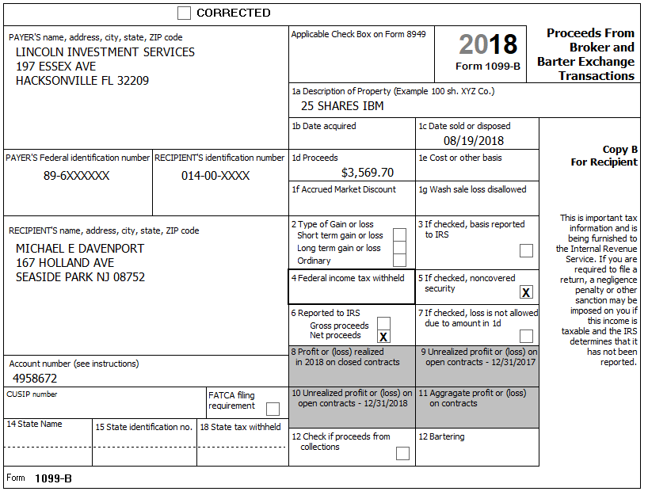

Secure Financial Services  2715 Financial Cir  Boston, MA 02110 | 2018 TAX REPORTING STATEMENT  Michael Davenport  167 Holland Ave, Seaside Park, NJ 08782  Account 111-227  RECIPIENT’S ID No: 014-00-XXXX  PAYER’S Federal ID No: 63-1XXXXXX

Dividends and Distributions – 1099-DIV – Reported to IRS
1a | Total ordinary dividends (includes line 1b) | 12,485.32
1b | Qualified dividends | 11,352.65
2a | Total capital gain distributions (includes lines 2b, 2c, 2d) | 0.00
2b | Unrecaptured Section 1250 gain | 0.00
2c | Section 1202 gain | 0.00
2d | Collectibles (28%) gain | 0.00
3 | Nondividend distributions | 14.75
4 | Federal Income tax withheld | 0.00
5 | Investment expenses | 0.00
6 | Foreign tax paid | 0.00
7 | Foreign country or US possession
8 | Cash liquidation distributions | 0.00
9 | Noncash liquidation distributions | 0.00
10 | Exempt-interest dividends (includes line 11) | 765.00
11 | Specified private activity bond interest dividends (AMT) | 125.00
12 | State
13 | State ID number | NJ
14 | State tax withheld | 0.00
 | FATCA filing requirement | NO
The tax-exempt interest on line 10 of the 1099-DIV is:
- $300 from Dreyfuss NJ Tax-Exempt Fund
- $465 from Fidelity Municipal Tax-Exempt Fund
- The following table is found in the brokerage statement

 | Dreyfus New Jersey Tax-Exempt Fund | Fidelity Municipal Tax-Exempt Fund
Puerto Rico Recovery Bonds | 5% | 9%
Federal Treasury Bonds | 4% | 1%
New York Thruway Bonds | 8% | 40%
New Jersey Turnpike Bonds | 81% | 45%
Misc | 2% | 5%

Interest Income – 1099-INT – Reported to IRS
1 | Interest Income | 850.00
2 | Early withdrawal penalty | 0.00
3 | Interest on US Savings Bonds & Treasury obligations | 0.00
4 | Federal Income tax withheld | 0.00
5 | Investment expenses | 0.00
6 | Foreign tax paid | 6.97
7 | Foreign country or US possession
8 | Tax-exempt interest | 975.00
9 | Specified private activity bond interest | 0.00
10 | Market Discount | 0.00
11 | Bond Premium | 0.00
13 | Bond Premium on Tax-Exempt Bond | 0.00
14 | Tax Exempt and Tax Credit Bond CUSIP No
15 | State | NJ
16 | State Identification No
17 | State Tax Withheld | 0.00
 | FATCA filing requirement
The tax-exempt interest on line 8 of the 1099-INT is:
- $400 from NJ Turnpike Bond
- $575 from Florida Municipal Bond.

FORM 1099-B 2018 Proceeds from Broker and Barter Exchange Transactions
Short-term transactions for which basis is reported to the IRS
Report on form 8949 with Box A checked and/or Schedule D, Part 1
(This label is a Substitute for Boxes 1 & 3) (IRS Form 1099-B box numbers are shown below in bold type)
1a Description, 2 Short-term, 3 Basis reported to IRS, 6 Net Proceeds and Stock or Other Symbol CUSIP
Quantity | 1b Date Acquired | 1c Date Sold | 1d Proceeds | 1e Cost or other Basis | 1f Code | 1g Adj | Gain / Loss (-) | 4 Federal Tax Withheld
Hillford Investment Fund
16.52300 | 09/23/2017 | 08/26/2018 | 169.36 | 142.58 |  |  | 26.78 | 0.00
15.87500 | 12/23/2017 | 08/26/2018 | 162.72 | 132.75 |  |  | 29.97 | 0.00
 |  |  | 332.08 |  |  | 0.00 | 56.75
Yuma Bond Fund
175.000 | 10/15/2017 | 02/26/2018 | 2,368.15 | 2,632.75 | W | 226.80 | -37.80 | 0.00
Totals |  |  | 2,700.23 | 2,908.08 |  | 226.80 | 18.95 | 0.00

FORM 1099-B 2017 Proceeds from Broker and Barter Exchange Transactions
Long-term transactions for which basis is reported to the IRS
Report on form 8949 with Box D checked and/or Schedule D, Part 1
(This label is a Substitute for Boxes 1 & 3) (IRS Form 1099-B box numbers are shown below in bold type)
1a Description, 2 Long-term, 3 Basis reported to IRS, 6 Net Proceeds and Stock or Other Symbol CUSIP
Quantity | 1b Date Acquired | 1c Date Sold | 1d Proceeds | 1e Cost or other Basis | 1f Code | 1g Adj | Gain / Loss (-) | 4 Federal Tax Withheld
Hillford Investment Fund
18.85400 | 03/26/2011 | 08/26/2018 | 193.25 | 159.45 |  |  | 33.80 | 0.00
17.76900 | 06/23/2011 | 08/26/2018 | 182.13 | 158.36 |  |  | 23.77 | 0.00
17.64500 | 09/23/2011 | 08/26/2018 | 180.87 | 162.74 |  |  | 18.13 | 0.00
17.52300 | 12/23/2011 | 08/26/2018 | 179.61 | 156.87 |  |  | 22.74 | 0.00
17.40000 | 03/23/2011 | 08/26/2018 | 178.35 | 150.74 |  |  | 27.61 | 0.00
17.27700 | 06/23/2012 | 08/26/2018 | 177.09 | 146.35 |  |  | 30.74 | 0.00
17.15400 | 09/23/2012 | 08/26/2018 | 175.83 | 142.58 |  |  | 33.25 | 0.00
17.03100 | 12/23/2012 | 08/26/2018 | 174.57 | 139.86 |  |  | 34.71 | 0.00
16.90800 | 03/23/2013 | 08/26/2018 | 173.31 | 140.85 |  |  | 32.46 | 0.00
16.78500 | 06/23/2013 | 08/26/2018 | 172.05 | 142.65 |  |  | 29.40 | 0.00
Totals |  |  | 1,787.05 | 1,500.45 |  | 0.00 | 286.61 | 0.00

